Wood, Thomas Harvey (Tom)
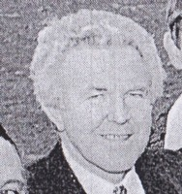
Worked for the Forests Department and CALM for over 40 years. At Dwellingup cadet school 1957-58. Commenced on staff 2.2.1959. In Mundaring in 1960s. In Grimwade 1966/67. Was Principal Health and Safety Officer. Retired 2000, lives near Collie.

